Final Project: CS 2450
Adam Carling
CS 2450
Curently, The system will output an arrow to the screen that scrolls down the screen. The player can press the coresponding keypad button and make the arrow disapear. The system is highly modular and customizable. The styles and config sheet can be changed to edit the general feel of the game without the need to edit any code.
The current design structure is as follows:
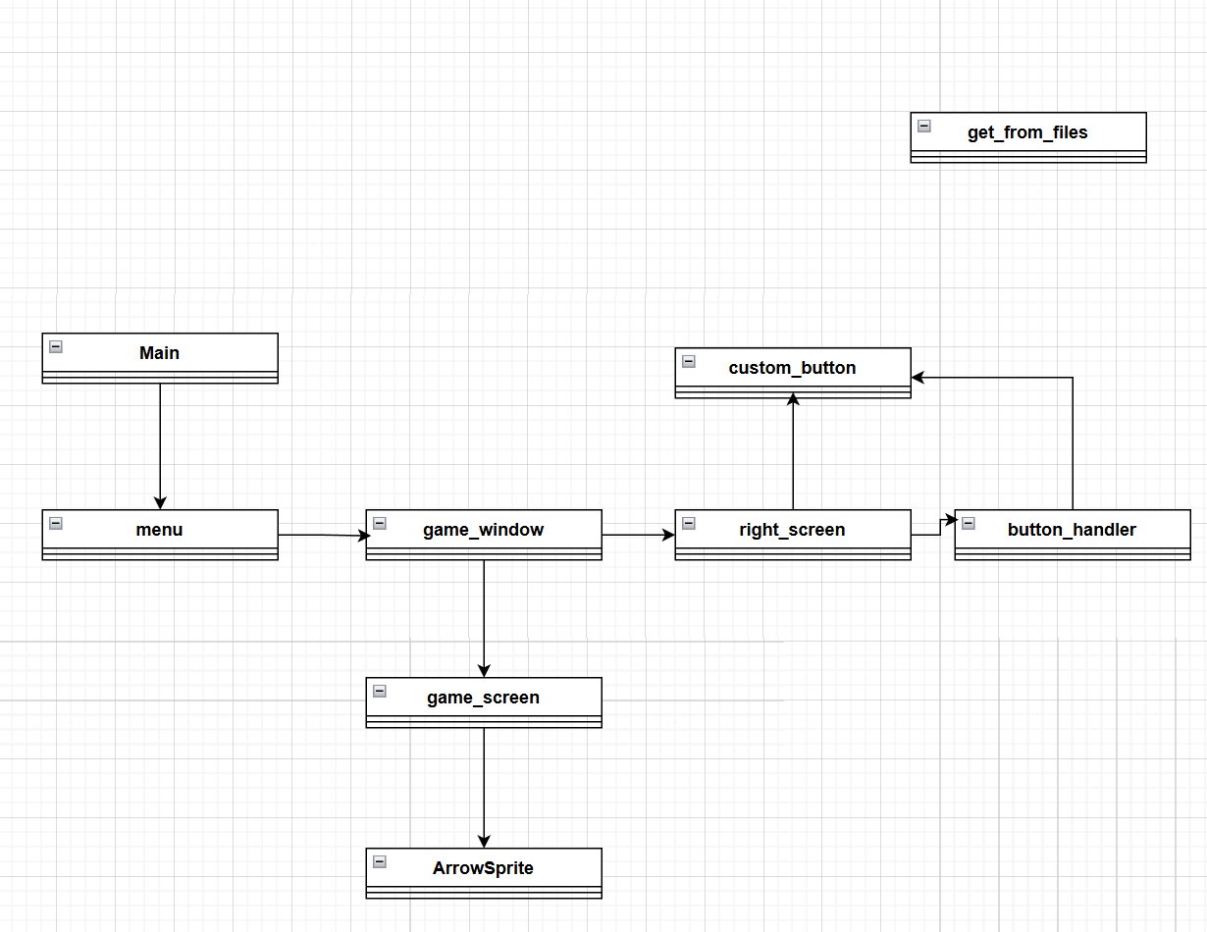
We used a highly modular design patern. Every class is in it own file and each class is only in charge of handling a few things. This allows for design changes and easy fixes to potential mistakes during design. Like possible thinking tkinter can be used to make a game and trying to use it for everything but realizing three classes in that it won’t work. Main and Menu classes are Tkinter windows but after that its all pygame-ce classes. The swap was seemless because of the design structure.
I use a button hanlder to contain all the logic for the buttons instead of trying to spread the buttons out across different classes. This allowed me to fix some issues with the
I use seperation of concerns. Each function only deals with one aspect of the code. Each class focuses on a clearly defined aspect of the code.
The factory pattern is used in left_screen.py for creating arrows to add new arrows to the scrolling screen.
The game is a poartial success from what we were hoping to implement with the stage one documentation. The feel of the game is unpolished and there is no music playing yet. Overall though, the design patters and class structure are there and the project is in a mostly deliverable state.

UnitTesting

